Science Reviewer
Chemical Reactions
Chemical Reactions:
- Chemical Reactions – Chemical reactions are processes in which one or more substances, called reactants, are transformed into new substances, called products, through the breaking and forming of chemical bonds. During a chemical reaction, atoms are rearranged, but they are not created or destroyed, in accordance with the law of conservation of mass.
- Descriptions – Chemical reactions involve changes at the molecular or atomic level, where reactants interact through collisions to break and form bonds, producing products with different chemical and physical properties, and energy is released (exothermic) or absorbed (endothermic).
- Exothermic Reactions – Release energy (heat/light/sound), warming surroundings.
- Endothermic Reactions – Absorb energy from surroundings, making them feel cold.
- Characteristics – Formation of new substances with distinct properties, rearrangement of atoms without changing their total number, energy change (heat, light, electricity, or sound may be produced or absorbed), and observable signs like color change, gas formation, precipitate formation, or temperature change.
- Types of Chemical Reactions:
- Combination (Synthesis) Reaction – A combination reaction is a type of chemical reaction where two or more simple substances combine to form a single compound, resulting in one product and is common in the formation of compounds.
- General Equation: A + B = AB
- Decomposition Reaction – A decomposition reaction is a type of chemical reaction where a single compound breaks down into two or more simpler substances, often requiring energy such as heat, light, or electricity, and is the opposite of combination reactions.
General Equation: $AB = A + B$
- Single Displacement (Replacement) Reaction – A single displacement reaction is a type of chemical reaction where one element replaces another element in a compound, occurring when one element is more reactive than the other and is common in metal reactions with acids.
- General Equation: $A + BC = AC + B$
- Double Displacement (Replacement) Reaction – A double displacement reaction is a type of chemical reaction where ions in two compounds exchange partners to form two new compounds, often occurring in aqueous solutions and may form a precipitate, gas, or water.
- General Equation: $AB + CD = AD + CB$
- Combustion Reaction – A combustion reaction is a type of chemical reaction where a substance reacts rapidly with oxygen, producing energy in the form of heat and light, usually involving hydrocarbons and serving as an important source of energy.
- General Equation: $fuel + O₂ → CO₂ + H₂O + energy$
- Acid-Base (Neutralization) Reaction – An acid-base reaction is a type of chemical reaction where an acid reacts with a base to produce salt and water, involving the transfer of protons (H⁺) and reducing acidity or basicity.
- Redox (Oxidation-Reduction) Reaction – A redox reaction is a type of chemical reaction involving the transfer of electrons between substances oxidation is the loss of electrons and reduction is the gain of electrons, and it occurs in many reaction types such as combustion and displacement reactions.
- Oxidation: loss of electrons
- Reduction: gain of electrons
- Occurs in many reaction types (combustion, displacement)

Predicting Chemical Reactions:
- Identify the type of reaction:
- Combination, Decomposition, Single/Double Displacement, Combustion, Acid-Base, Redox.
- Use the general reaction pattern:
- Combination: A + B → AB
- Decomposition: AB → A + B
- Single displacement: A + BC → AC + B
- Double displacement: AB + CD → AD + CB
- Combustion: Hydrocarbon + O₂ → CO₂ + H₂O
- Acid-Base: Acid + Base → Salt + H₂O
- Determine the products:
- For single displacement, the more reactive element replaces the less reactive one.
- For double displacement, cations and anions switch partners.
- For combustion, always produce CO₂ and H₂O.
- Write formulas correctly:
- Use charges for ionic compounds (e.g., Na⁺ + SO₄²⁻ → Na₂SO₄).
- Use molecular formulas for covalent compounds.
- Write the unbalanced equation with reactants and predicted products.
- Balance the equation as in the previous examples.
1. Combination (Synthesis) Reaction
Given: Magnesium + Oxygen → ?
Step-by-Step Prediction:
- Identify reaction type: Combination (two elements → one compound).
- Predict product: Magnesium oxide (MgO).
- Write unbalanced equation:
$$Mg+O_{2}→MgO$$
- Count atoms:
  - Left: Mg=1, O=2
  - Right: Mg=1, O=1
- Balance oxygen (O):
  - Right has 1 O → put 2 in front of MgO → Mg + O₂ → 2 MgO
  - Now O: Left=2, Right=2 ✅
- Balance magnesium (Mg):
  - Right: 2 Mg → put 2 in front of Mg on left → 2 Mg + O₂ → 2 MgO
✅ Balanced Equation:
$$2Mg+O_{2}→2MgO$$
2. Decomposition Reaction
Given: Sodium bicarbonate → ?
Step-by-Step Prediction:
- Identify reaction type: Decomposition (one compound → simpler substances).
- Predict products: Sodium carbonate + Water + Carbon dioxide → Na₂CO₃ + H₂O + CO₂
- Write unbalanced equation:
$$NaHCO_{3}→Na_{2}CO_{3}+H_{2}O+CO_{2}$$
- Count atoms:
  - Left: Na=1, H=1, C=1, O=3
  - Right: Na=2, H=2, C=2, O=6
- Balance sodium (Na):
  - Left Na=1 → Right Na=2 → multiply NaHCO₃ by 2 → 2 NaHCO₃ → Na₂CO₃ + H₂O + CO₂
- Balance hydrogen (H):
  - Left: H=2 → Right: H=2 ✅
- Balance carbon (C):
  - Left: 2 C → Right: C=1+1=2 ✅
- Balance oxygen (O):
  - Left: 2×3=6 O → Right: Na₂CO₃=3, H₂O=1, CO₂=2 → total=6 ✅
✅ Balanced Equation:
$$2NaHCO_{3}→Na_{2}CO_{3}+H_{2}O+CO_{2}$$
3. Single Displacement Reaction
Given: Aluminum + Copper(II) chloride → ?
Step-by-Step Prediction:
- Identify reaction type: Single displacement (metal + ionic compound → new metal + ionic compound).
- Predict products: Aluminum chloride + Copper → AlCl₃ + Cu
- Write unbalanced equation:
$$Al+CuCl_{2}→AlCl_{3}+Cu$$
- Count atoms:
  - Left: Al=1, Cu=1, Cl=2
  - Right: Al=1, Cl=3, Cu=1
- Balance chlorine (Cl):
  - LCM of 2 and 3 = 6 → multiply CuCl₂ by 3 and AlCl₃ by 2
$$2Al+3CuCl_{2}→2AlCl_{3}+3Cu$$
- Check aluminum (Al) and copper (Cu):
  - Al: 2 → 2 ✅
  - Cu: 3 → 3 ✅
✅ Balanced Equation:
$$2Al+3CuCl_{2}→2AlCl_{3}+3Cu$$
4. Double Displacement Reaction
Given: Lead(II) nitrate + Potassium iodide → ?
Step-by-Step Prediction:
- Identify reaction type: Double displacement (exchange of ions).
- Predict products: Lead(II) iodide + Potassium nitrate → PbI₂ + KNO₃
- Write unbalanced equation:
$$Pb(NO_{3})_{2}+KI→PbI_{2}+KNO_{3}$$
- Count atoms:
  - Left: Pb=1, K=1, N=2, O=6, I=1
  - Right: Pb=1, I=2, K=1, N=1, O=3
- Balance potassium (K) and nitrate (NO₃):
  - Right: N=1 → put 2 in front of KNO₃ → Pb(NO₃)₂ + 2 KI → PbI₂ + 2 KNO₃
- Balance iodine (I):
  - Left: 2 I (2 KI) → Right: PbI₂=2 ✅
✅ Balanced Equation:
$$Pb(NO_{3})_{2}+2KI→PbI_{2}+2KNO_{3}$$
5. Combustion Reaction
Given: Butane + Oxygen → ?
Step-by-Step Prediction:
- Identify reaction type: Combustion (hydrocarbon + O₂ → CO₂ + H₂O).
- Predict products: CO₂ + H₂O
- Write unbalanced equation:
$$C_{4}H_{10}+O_{2}→CO_{2}+H_{2}O$$
- Balance carbon (C):
  - Left C=4 → Right C=1 → put 4 in front of CO₂ → C₄H₁₀ + O₂ → 4 CO₂ + H₂O
- Balance hydrogen (H):
  - Left H=10 → Right H₂O=2 → put 5 in front of H₂O → C₄H₁₀ + O₂ → 4 CO₂ + 5 H₂O
- Balance oxygen (O):
  - Right O: 4×2=8 + 5×1=5? Wait, water has 2 O → 5 H₂O = 5×1? No: H₂O=2 O? Wait, 2 H in H₂O, O=1, yes. So 5 H₂O=5 O
  - Total O on right = 8+5=13 O
  - Left: O₂ → 13/2 O₂ → multiply everything by 2 → 2 C₄H₁₀ + 13 O₂ → 8 CO₂ + 10 H₂O
✅ Balanced Equation:
$$2C_{4}H_{10}+13O_{2}→8CO_{2}+10H_{2}O$$
6. Acid-Base (Neutralization) Reaction
Given: Phosphoric acid + Sodium hydroxide → ?
Step-by-Step Prediction:
- Identify reaction type: Acid-base → salt + water
- Predict products: Sodium phosphate + water → Na₃PO₄ + H₂O
- Write unbalanced equation:
$$H_{3}PO_{4}+NaOH→Na_{3}PO_{4}+H_{2}O$$

- Count atoms:
  - Left: H=3+1=4, Na=1, P=1, O=4+1=5
  - Right: Na=3, P=1, O=4+1=5, H=2
- Balance sodium (Na):
  - Left: Na=1 → Right Na=3 → multiply NaOH by 3 → H₃PO₄ + 3 NaOH → Na₃PO₄ + H₂O
- Balance hydrogen (H):
  - Left H: 3 + 3×1=6 → Right: H₂O=2 → put 3 in front of H₂O → H₃PO₄ + 3 NaOH → Na₃PO₄ + 3 H₂O
✅ Balanced Equation:
$$H_{3}PO_{4}+3NaOH→Na_{3}PO_{4}+3H_{2}O$$
7. Redox (Oxidation-Reduction) Reaction
Given: Iron + Silver nitrate → ?
Step-by-Step Prediction:
- Identify reaction type: Single displacement + redox (Fe replaces Ag)
- Predict products: Iron(II) nitrate + Silver → Fe(NO₃)₂ + Ag
- Write unbalanced equation:
$$Fe+AgNO_{3}→Fe(NO_{3})_{2}+Ag$$
- Count atoms:
  - Left: Fe=1, Ag=1, N=1, O=3
  - Right: Fe=1, Ag=1, N=2, O=6
- Balance nitrate (NO₃):
  - Right has 2 → put 2 in front of AgNO₃ → Fe + 2 AgNO₃ → Fe(NO₃)₂ + Ag
- Balance silver (Ag):
  - Left: 2 Ag → Right: 1 → put 2 in front of Ag → Fe + 2 AgNO₃ → Fe(NO₃)₂ + 2 Ag
✅ Balanced Equation:
$$Fe+2AgNO_{3}→Fe(NO_{3})_{2}+2Ag$$

Balancing Chemical Reactions:
- Balancing chemical reactions means making sure that the number of atoms of each element is the same on both sides of the equation (Law of Conservation of Mass).
- Step 1: Write the unbalanced equation
- Write the reactants on the left and products on the right. Include the formulas of compounds.
- Step 2: Count atoms for each element
- List how many atoms of each element are on both sides.
- Step 3: Balance one element at a time
- Start with elements that appear only once on each side.
- Save hydrogen (H) and oxygen (O) for last if they appear in multiple compounds.
- Step 4: Use coefficients, not subscripts
- Coefficients are numbers placed before compounds to balance.
- Never change the chemical formula itself; that would change the substance.
- Step 5: Check your work
- Count atoms again to ensure both sides have the same number of atoms for each element.
- Make sure coefficients are in smallest whole numbers.
1. Combination (Synthesis) Reaction
Reaction: Aluminum + Oxygen → Aluminum oxide
Unbalanced Equation:
$$Al+O_{2}→Al_{2}O_{3}$$
Step-by-Step:
- Write the formulas correctly:
  - Reactants: Al, O₂
  - Product: Al₂O₃
- Count atoms on each side:
  - Left: Al = 1, O = 2
  - Right: Al = 2, O = 3
- Balance aluminum (Al) first:
  - Right has 2 Al → put 2 in front of Al on left:
2 Al + O_2 → Al_2O_3
]
- Al: Left = 2, Right = 2 ✅
- Balance oxygen (O):
  - Right: 3 O in Al₂O₃
  - Left: O₂ → 2 O atoms
  - Find least common multiple (LCM) of 2 and 3 → LCM = 6
  - Multiply Al₂O₃ by 2 → 2 Al₂O₃ = 4 Al, 6 O
  - Multiply Al by 4 → 4 Al
  - Multiply O₂ by 3 → 3 O₂ = 6 O
$$4Al+3O_{2}→2Al_{2}O_{3}$$
- Check atoms:
  - Al: Left = 4, Right = 4 ✅
  - O: Left = 3×2=6, Right = 2×3=6 ✅
✅ Balanced Equation:
$$4Al+3O_{2}→2Al_{2}O_{3}$$
2. Decomposition Reaction
Reaction: Potassium chlorate → Potassium chloride + Oxygen
Unbalanced Equation:
$$KClO_{3}→KCl+O_{2}$$
Step-by-Step:
- Write formulas correctly:
  - Reactant: KClO₃
  - Products: KCl + O₂
- Count atoms:
  - Left: K=1, Cl=1, O=3
  - Right: K=1, Cl=1, O=2

- Balance oxygen (O):
  - Left: 3 O
  - Right: 2 O in O₂
  - LCM of 3 and 2 = 6 → Multiply KClO₃ by 2 → 2 KClO₃ = 2 K, 2 Cl, 6 O
  - Multiply O₂ by 3 → 3 O₂ = 6 O
  - Multiply KCl by 2 → 2 KCl = 2 K, 2 Cl
$$2KClO_{3}→2KCl+3O_{2}$$
- Check atoms:
  - K: Left = 2, Right = 2 ✅
  - Cl: Left = 2, Right = 2 ✅
  - O: Left = 6, Right = 3×2=6 ✅
✅ Balanced Equation:
$$2KClO_{3}→2KCl+3O_{2}$$
3. Single Displacement Reaction
Reaction: Copper + Silver nitrate → Copper(II) nitrate + Silver
Unbalanced Equation:
$$Cu+AgNO_{3}→Cu(NO_{3})_{2}+Ag$$
Step-by-Step:
- Write formulas correctly:
  - Reactants: Cu, AgNO₃
  - Products: Cu(NO₃)₂, Ag
- Count atoms:
  - Left: Cu=1, Ag=1, N=1, O=3
  - Right: Cu=1, Ag=1, N=2, O=6
- Balance nitrate (NO₃) groups:
  - Right has 2 NO₃ → put 2 in front of AgNO₃ → 2 AgNO₃
$$Cu+2AgNO_{3}→Cu(NO_{3})_{2}+Ag$$
- Balance silver (Ag):
  - Left: 2 Ag (2 AgNO₃) → Right: 1 Ag → put 2 in front of Ag
$$Cu+2AgNO_{3}→Cu(NO_{3})_{2}+2Ag$$
- Check atoms:
  - Cu: Left=1, Right=1 ✅
  - Ag: Left=2, Right=2 ✅
  - N: Left=2, Right=2 ✅
  - O: Left=6, Right=6 ✅
✅ Balanced Equation:
$$Cu+2AgNO_{3}→Cu(NO_{3})_{2}+2Ag$$
4. Double Displacement Reaction
Reaction: Barium chloride + Sodium sulfate → Barium sulfate + Sodium chloride
Unbalanced Equation:
$$BaCl_{2}+Na_{2}SO_{4}→BaSO_{4}+NaCl$$

Step-by-Step:
- Write formulas correctly:
  - Reactants: BaCl₂, Na₂SO₄
  - Products: BaSO₄, NaCl
- Count atoms:
  - Left: Ba=1, Cl=2, Na=2, S=1, O=4
  - Right: Ba=1, S=1, O=4, Na=1, Cl=1
- Balance sodium (Na) and chlorine (Cl):
  - Left: Na=2 → Right: Na=1 → put 2 in front of NaCl
$$BaCl_{2}+Na_{2}SO_{4}→BaSO_{4}+2NaCl$$
- Check atoms:
  - Ba: 1 ✅
  - Cl: Left=2, Right=2 ✅
  - Na: Left=2, Right=2 ✅
  - S: 1 ✅
  - O: 4 ✅
✅ Balanced Equation:
$$BaCl_{2}+Na_{2}SO_{4}→BaSO_{4}+2NaCl$$
5. Combustion Reaction
Reaction: Propane + Oxygen → Carbon dioxide + Water
Unbalanced Equation:
$$C_{3}H_{8}+O_{2}→CO_{2}+H_{2}O$$
Step-by-Step:
- Count atoms:
  - Left: C=3, H=8, O=2
  - Right: C=1, H=2, O=3
- Balance carbon (C) first:
  - Left C=3 → Right C=1 → put 3 in front of CO₂
$$C_{3}H_{8}+O_{2}→3CO_{2}+H_{2}O$$
- Balance hydrogen (H):
  - Left H=8 → Right H=2 in H₂O → put 4 in front of H₂O
$$C_{3}H_{8}+O_{2}→3CO_{2}+4H_{2}O$$
- Balance oxygen (O):
  - Right: 3 CO₂ = 6 O, 4 H₂O = 4 O → Total O = 10
  - Left: O₂ → 10/2 = 5 → put 5 in front of O₂
$$C_{3}H_{8}+5O_{2}→3CO_{2}+4H_{2}O$$
- Check atoms:
  - C: Left=3, Right=3 ✅
  - H: Left=8, Right=8 ✅
  - O: Left=5×2=10, Right=3×2 +4×1×2=10 ✅
✅ Balanced Equation:
$$C_{3}H_{8}+5O_{2}→3CO_{2}+4H_{2}O$$
6. Acid-Base (Neutralization) Reaction
Reaction: Sulfuric acid + Sodium hydroxide → Sodium sulfate + Water
Unbalanced Equation:
$$H_{2}SO_{4}+NaOH→Na_{2}SO_{4}+H_{2}O$$
Step-by-Step:
- Count atoms:
  - Left: H=2+1=3, Na=1, S=1, O=4+1=5
  - Right: Na=2, S=1, O=4+1=5, H=2 ✅
- Balance sodium (Na):
  - Left Na=1 → Right Na=2 → put 2 in front of NaOH
$$H_{2}SO_{4}+2NaOH→Na_{2}SO_{4}+H_{2}O$$
- Check hydrogen (H):
  - Left: H₂SO₄=2 H, 2 NaOH=2 H → Total=4 H
  - Right: H₂O=2 H → need 2 H₂O → put 2 in front of H₂O?
$$H_{2}SO_{4}+2NaOH→Na_{2}SO_{4}+2H_{2}O$$
- Check atoms:
  - H: Left=2+2=4, Right=2×2=4 ✅
  - Na: 2 ✅
  - S: 1 ✅
  - O: Left=4+2=6, Right=4+2=6 ✅
✅ Balanced Equation:
$$H_{2}SO_{4}+2NaOH→Na_{2}SO_{4}+2H_{2}O$$
7. Redox (Oxidation-Reduction) Reaction
Reaction: Magnesium + Hydrochloric acid → Magnesium chloride + Hydrogen gas
Unbalanced Equation:
$$Mg+HCl→MgCl_{2}+H_{2}$$
Step-by-Step:
- Write formulas correctly:
  - Reactants: Mg, HCl
  - Products: MgCl₂, H₂
- Count atoms:
  - Left: Mg=1, H=1, Cl=1
  - Right: Mg=1, Cl=2, H=2
- Balance chlorine (Cl) first:
  - Left Cl=1 → Right Cl=2 → put 2 in front of HCl
$$Mg+2HCl→MgCl_{2}+H_{2}$$
- Check hydrogen (H):
  - Left: H=2 → Right: H=2 ✅
- Check magnesium (Mg):
  - Left=1, Right=1 ✅
✅ Balanced Equation:
$$Mg+2HCl→MgCl_{2}+H_{2}$$

Naming Chemical Reactions:
1. Naming Elements (Chemical Symbols)
Rules:
- Every element has a symbol (1–2 letters).
- The first letter is always uppercase.
- If there’s a second letter, it is always lowercase.
- Symbols can come from:
  - English name → e.g., Carbon → C, Oxygen → O
  - Latin/Greek name → e.g., Sodium → Na (Natrium), Gold → Au (Aurum)
- Never change the order of letters in a symbol.
Fixed Rule Summary:
- Capitalize first letter, lowercase second if present.
- Use official symbol from periodic table (cannot invent letters).

2. Naming Compounds
A. Ionic Compounds (Metal + Non-metal)
Rules:
- Name the metal first, then the non-metal.
- Change the non-metal ending to -ide.
  - Example: Cl⁻ → Chloride, O²⁻ → Oxide
- If the metal can have multiple charges (transition metals), use Roman numerals to show its charge.
  - Example: Fe²⁺ → Iron(II), Fe³⁺ → Iron(III)
Fixed Rule Summary:
- Metal → unchanged
- Non-metal → end with -ide
- Transition metals → Roman numeral charge

B. Covalent Compounds (Non-metal + Non-metal)
Rules:
- Use prefixes to show number of atoms:
  - mono- = 1, di- = 2, tri- = 3, tetra- = 4, penta- = 5, hexa- = 6
- The first element only gets “mono-” if needed; second always gets prefix.
- Change the second element’s ending to -ide.
Fixed Rule Summary:
- Use numeric prefixes
- Change second element ending to -ide
- First element “mono-” optional

Reaction Type | General Formula | Naming Rule
Synthesis / Combination | A + B → AB | Name as “Formation of …”
Decomposition | AB → A + B | Name as “Decomposition of …”
Single Replacement | A + BC → AC + B | Name as “X displaces Y from Z”
Double Replacement | AB + CD → AD + CB | Name as “Exchange reaction” or “Precipitation of …”
Combustion | Hydrocarbon + O₂ → CO₂ + H₂O | Name as “Combustion of …”

Types of Chemical Bonds:
- Ionic Bond – Complete transfer of electrons from one atom to another. One atom loses electrons → becomes a cation (+), the other gains electrons → becomes an anion (−). The strong electrostatic attraction between opposite charges holds the compound together.
$$Metal+Nonmetal$$
- Covalent Bond - Sharing of electron pairs between atoms so both achieve a stable valence shell (octet rule). Electrons are localized between nuclei forming a shared electron cloud.
$$Nonmetal+Nonmetal$$
- Metallic Bond – Electrons are delocalized and move freely in a “sea of electrons” surrounding positive metal ions. No single electron belongs to one atom.
$$Metal+Metal$$

Calculating Molecular Mass:
- Chemical Composition by Mass – The chemical composition by mass (or mass percent) tells you how much of each element is present in a compound, expressed as a percentage of the total mass of the compound.
$$Element Molecular Mass Percentage=\frac{Singular Element Mass in Total}{Total Molecular Mass in Element}×100$$

Periodic Table
Classifications in the Periodic Table:
- Metalloids - These have the intermediate properties of metals and non-metals. These form a zigzag in the periodic table. They are boron, silicon, germanium, arsenic, antimony, tellurium, and polonium.
- Metallic Elements – They are found on the left side and the lower parts of the periodic table.
- Non-Metals - They are placed on the upper right part of the periodic table.

Symbols of the Periodic Table:
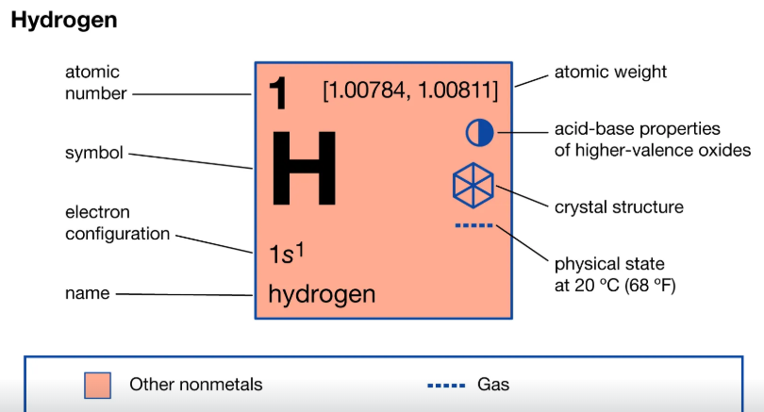
Groups and Periods:
- Groups – Is a column in a periodic table
- Periods – Is a row in a periodic table
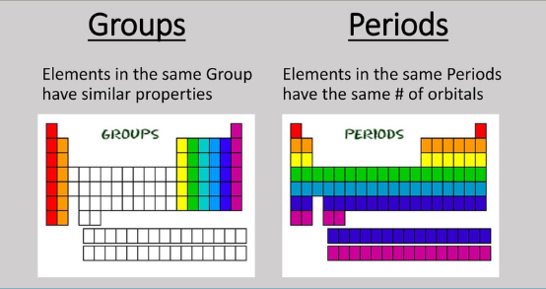
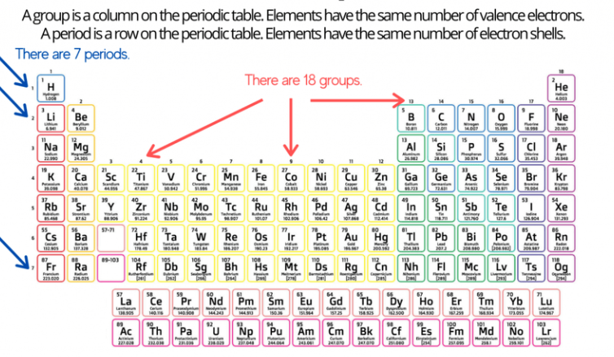

Groups in the Periodic Table:
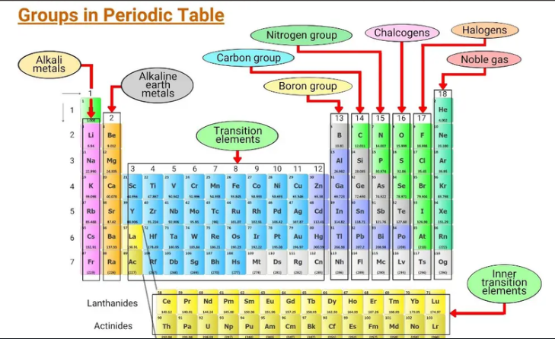

Group Number and Valence Electrons:
IUPAC Numbering Scheme | Old Notation (US) Scheme | Name of the Family | Valence Electrons | Metal or Non Metal
1 | IA | Alkali Metals | 1 | Metal
2 | IIA | Alkaline Earth Metals | 2 | Metal
13 | IIIA | Boron Group | 3 | Mostly Metals
14 | IVA | Carbon Group | 4 | Mixed
15 | VA | Nitrogen Group | 5 | Mostly Nonmetals
16 | VIA | Chalcogens | 6 | Mostly Non Metals
17 | VIIA | Halogens | 7 | Non Metals
18 | VIIIA | Noble or Inert Gases | 8 | Nonmetals

Exceptions Metals and Non-metals
Group | Family | Exception Elements (Actual Type)
1 | Alkali Metals | Hydrogen (H) – Nonmetal
13 | Boron Group | Boron (B) – Metalloid
14 | Carbon Group | Carbon (C) – Nonmetal  Silicon (Si) – Metalloid; Germanium (Ge) – Metalloid
15 | Nitrogen Group | Arsenic (As) – Metalloid; Antimony (Sb) – Metalloid; Bismuth (Bi) – Metal
16 | Chalcogens | Tellurium (Te) – Metalloid; Polonium (Po) – Metal

